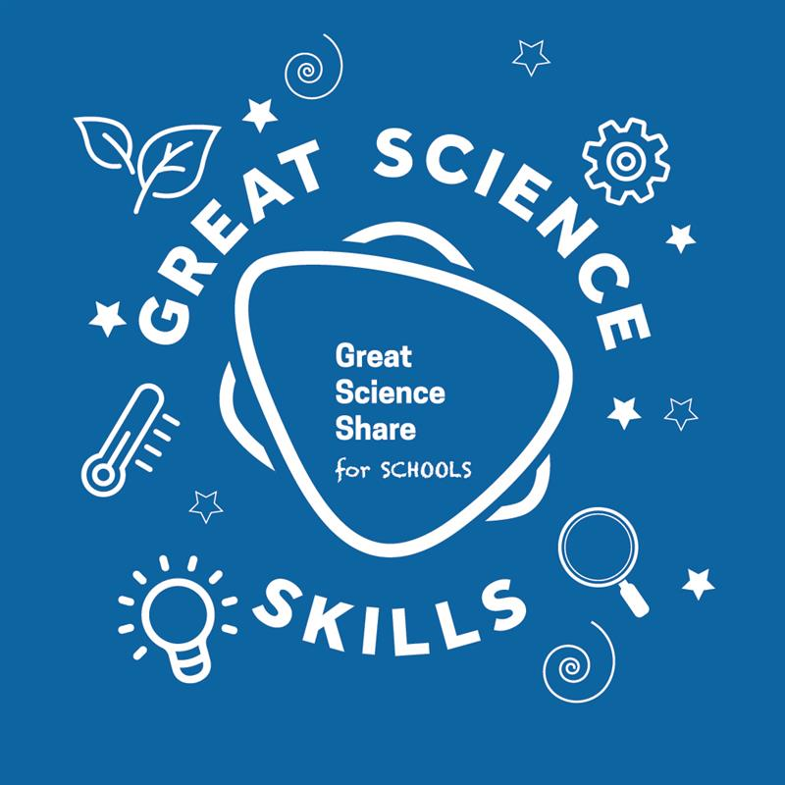
GREAT SCIENCE SKILLS STARTERS

Teacher notes
5-7 years: Asking Questions

Children need to develop their scientific skills through enquiries that are clearly related to the science knowledge they are developing. Children need to be explicitly taught science skills such as asking relevant scientific questions, carrying out simple tests, gathering and recording evidence and using that evidence to answer questions, to help them develop greater independence in carrying out their own investigations.

These teacher notes and the accompanying video are designed to help younger children develop skills in asking scientific questions, a skill at is required at both the beginning and the end of the scientific process.

The questioning stage of the scientific process
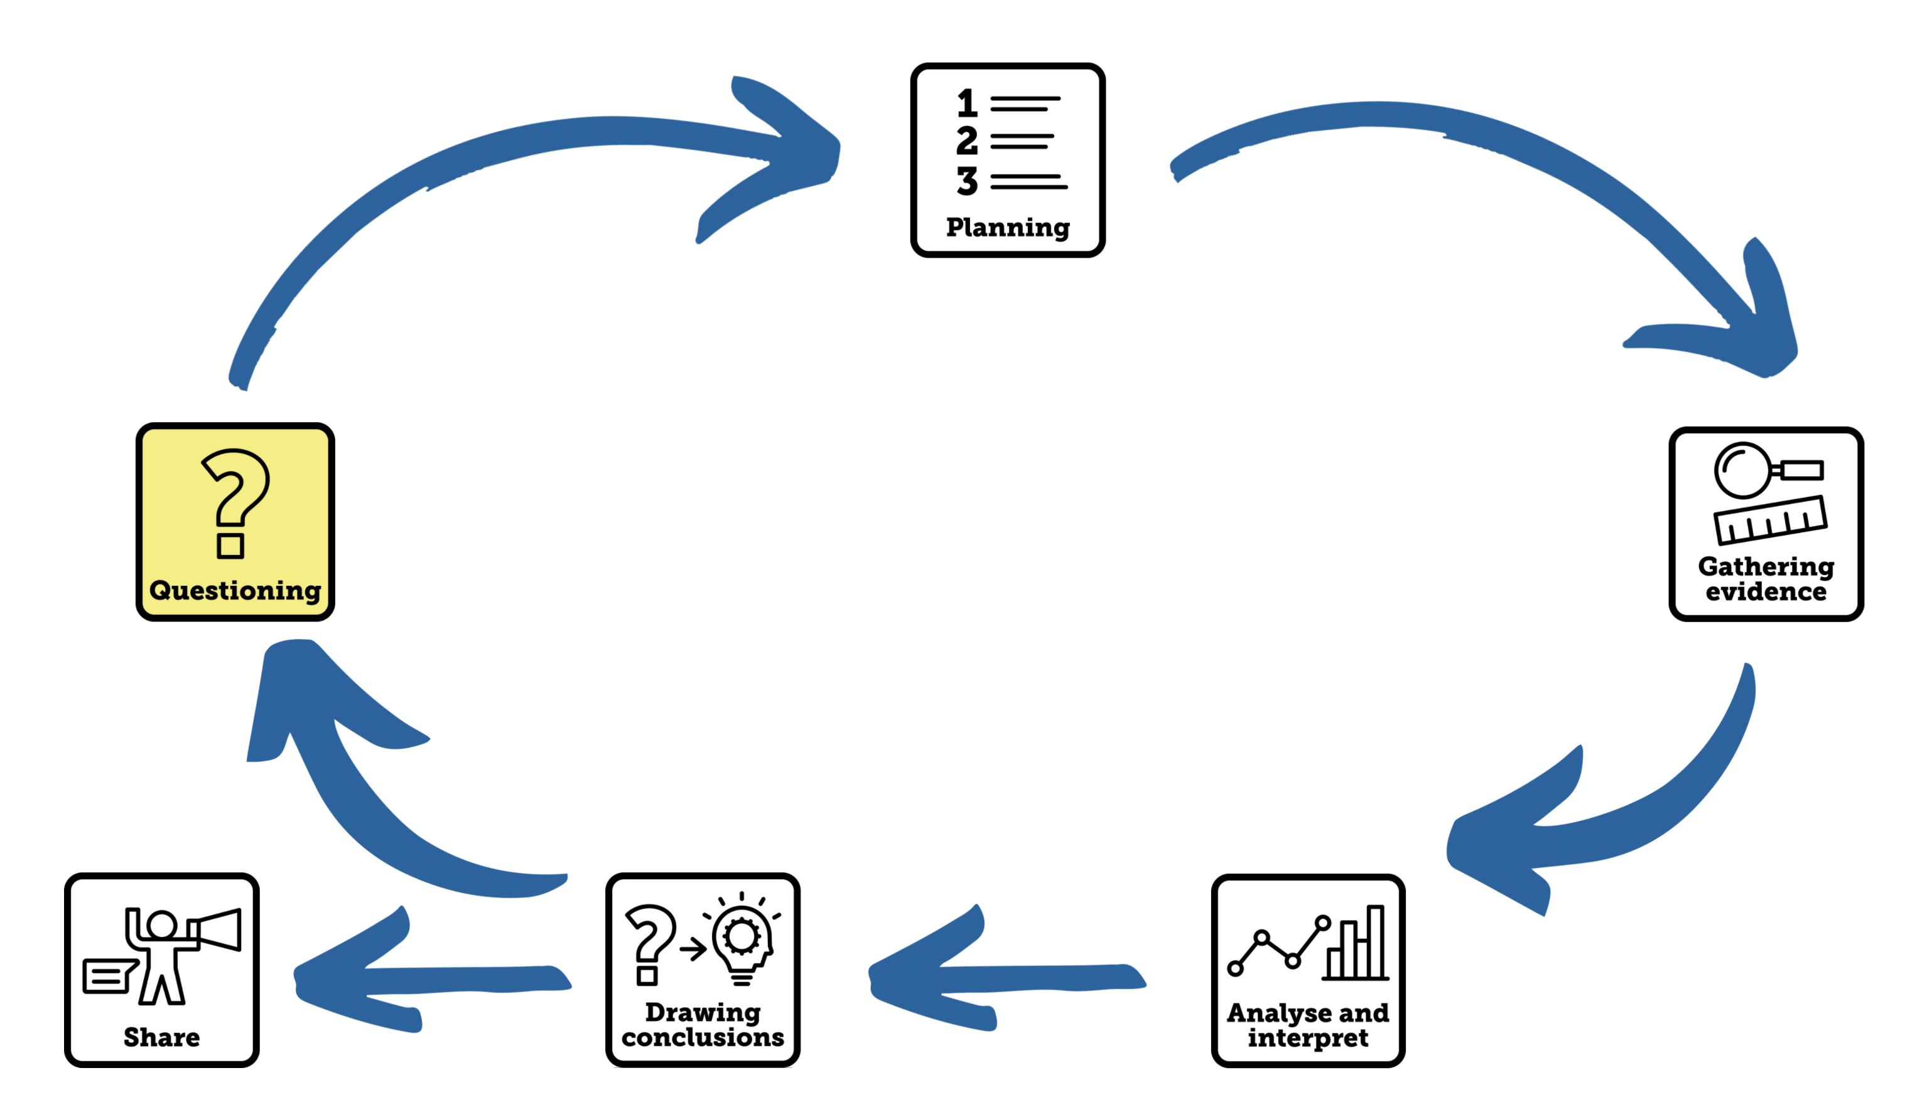

Aim of the video
This Science Skills Starter video is a resource to encourage children to develop their own questions that could be developed into investigations. Scientific questions mark the start of the scientific process for 5-7 year olds yet often conclusions can also lead children to ask further questions and the process begins again. It’s important for teachers to find ways for children to share their scientific questions with new audiences in new ways. Use the Share Spinner and Share Dice to engage your children to think about how they might share their questions.

Using the video
- The video begins with Dr Chips being curious about different flowers. He models the skills of asking scientific questions by asking questions about the flowers in the vase. Encourage your children to focus on the questions he is asking, the vocabulary he uses and how finding the answers to those questions will help us know more about flowers.
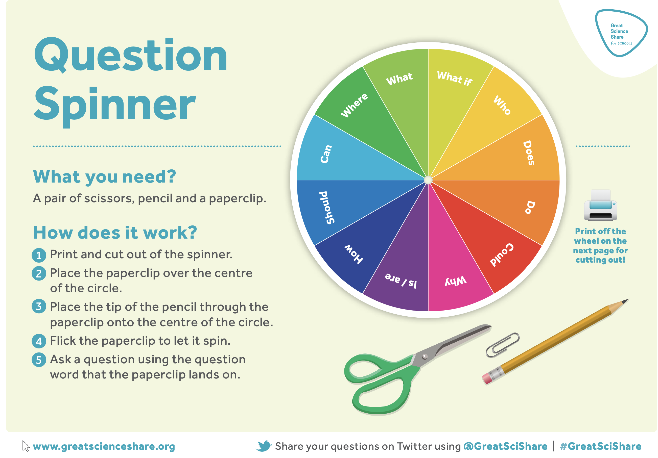
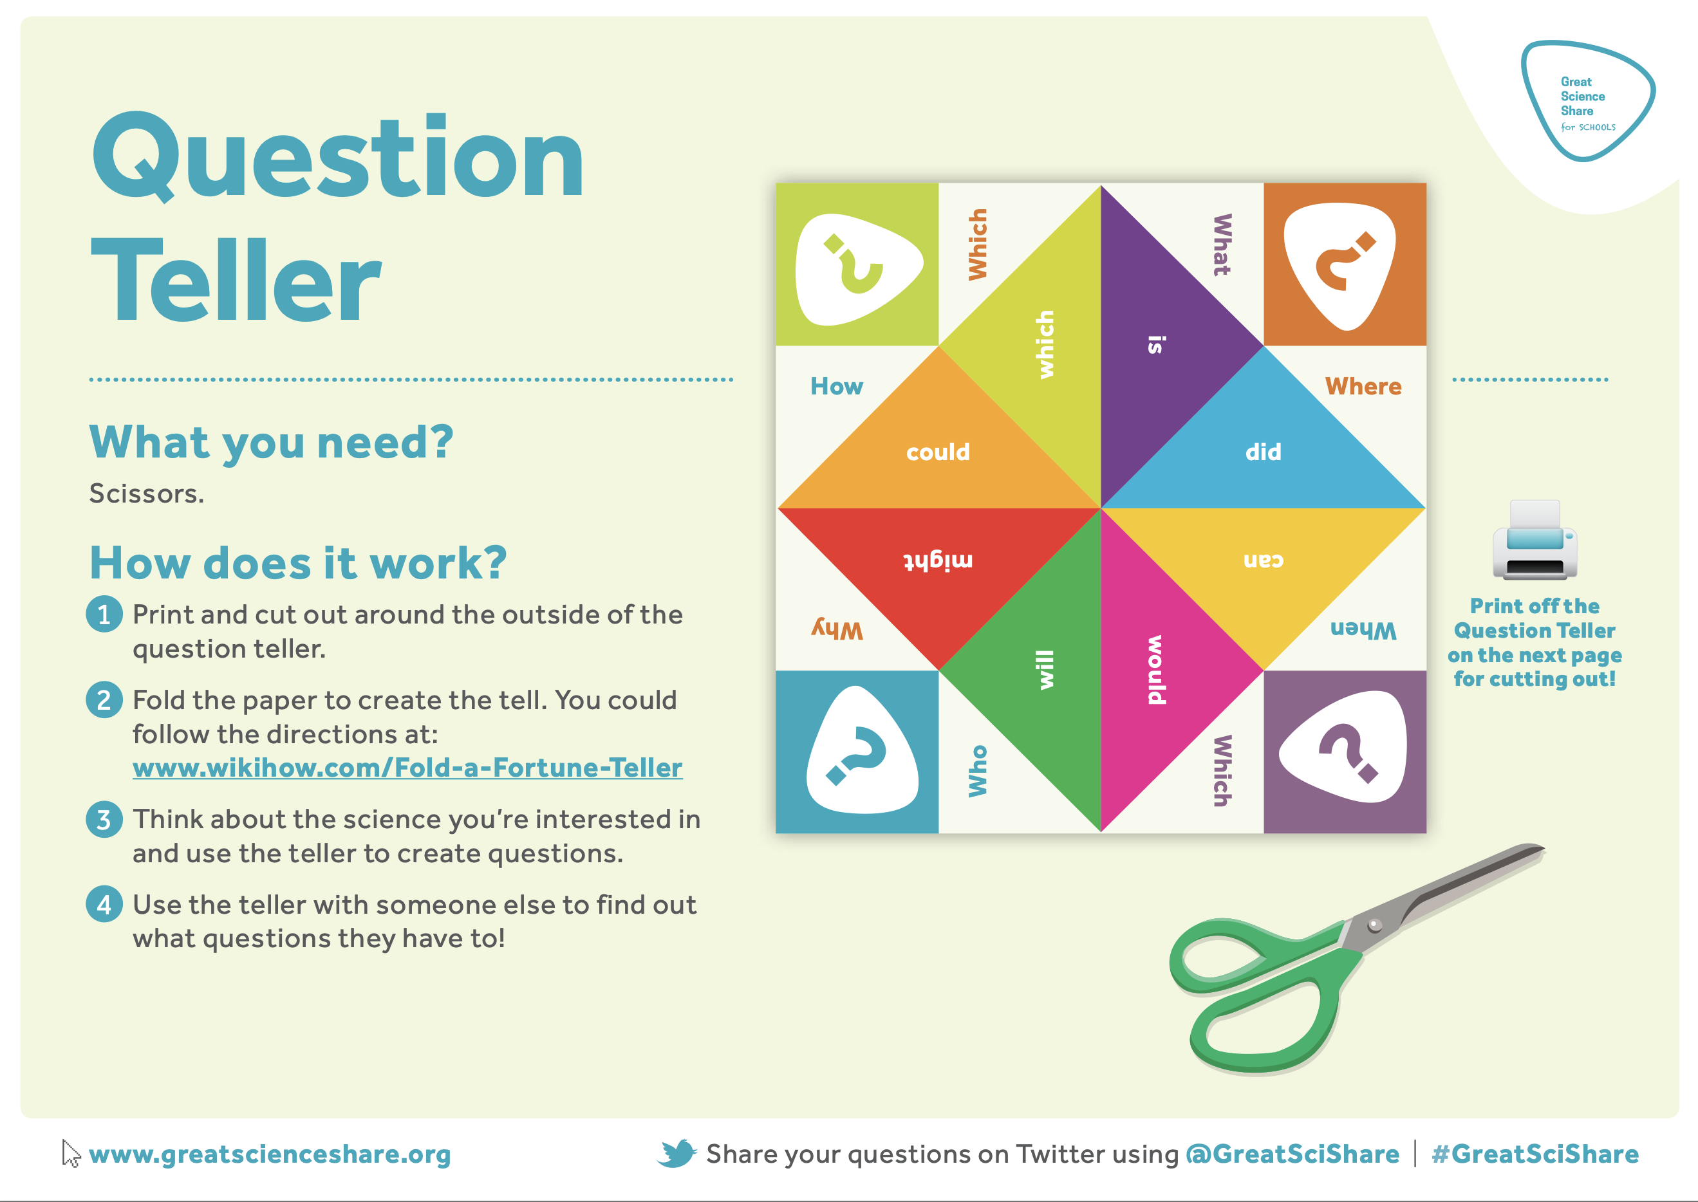
- The children are then shown a floating and sinking demonstration to inspire curiosity and question-asking.

Pause the video here and encourage the children to collaborate to come up with lists of questions about floating and sinking.

Provide groups of children with our Question Makers to inspire them to form a variety of questions. The Question Spinner gives a children a range of openings for their questions or the Question Hand could give children a clear target to meet with phrases such as:

  - Why does …?
  - What if…?
  - I wonder if …?
  - When would…?
- The video ends by linking the skill that has been learnt to the children’s current science learning. You could mirror this activity in your own classroom with an image, object or demonstration that links to your science topic as a hook for children to generate their own questions. Use formative assessment and feedback to really focus on planning as a skill.

Tips to further develop this skill with your children
- Set up a question wall or door in your classroom where children are encouraged to regularly display the scientific questions they come up with over the year, this can be used to really celebrate children’s curiosity and thinking. Why not have a Science Question of the week?
- Establish a scientific question post-box where children can post their questions in relation to the current topic there are learning about in science. Make time to sort the questions at the end of each topic and organise children into groups to try and gather evidence to answer some of them.
- Encourage parents and carers to develop scientific questions at home linked to your current science topic, this has the added benefits of children seeing connections between their world and their science learning as well as sharing their learning with their families. You could scaffold this home learning with a Question Hand – write what children should be curious about on the palm and the question stems on the fingers.

Author: Amanda Poole
Editor: Dr Lynne Bianchi

Disclaimer: The Great Science Share for Schools are not liable for the actions of activity of any persons who uses this resource or in any of the suggested further resources. We assume no liability with regard to injuries or damage to property that may occur as a result of using this information. These activities are designed to be carried out by children working with an adult. The adult is fully responsible for ensuring the activity is carried out safely. You can access further H&S advice from www.cleapss.org.uk.

© 2022 The University of Manchester. These resources have been produced by the Great Science Share for Schools’ team. For more information visit www.greatscienceshare.org or contact greatscishare@manchester.ac.uk.

