GREAT SCIENCE SKILLS STARTERS

Teacher notes
5-7 years: Drawing Conclusions

Children need to develop their scientific skills through enquiries that are clearly related to the science knowledge they are developing. Children need to be explicitly taught science skills such as asking relevant questions, carrying out simple tests, gathering and recording evidence and using that evidence to answer questions, to help them develop greater independence in carrying out their own investigations.

These teacher notes and the accompanying video are designed to help younger children develop the skill of using the evidence they have collected to answer scientific questions by drawing a conclusion, the accompanying Focus Frames and Conclusion Creators are designed to support children in practicing this skill independently.

The concluding stage of the scientific process
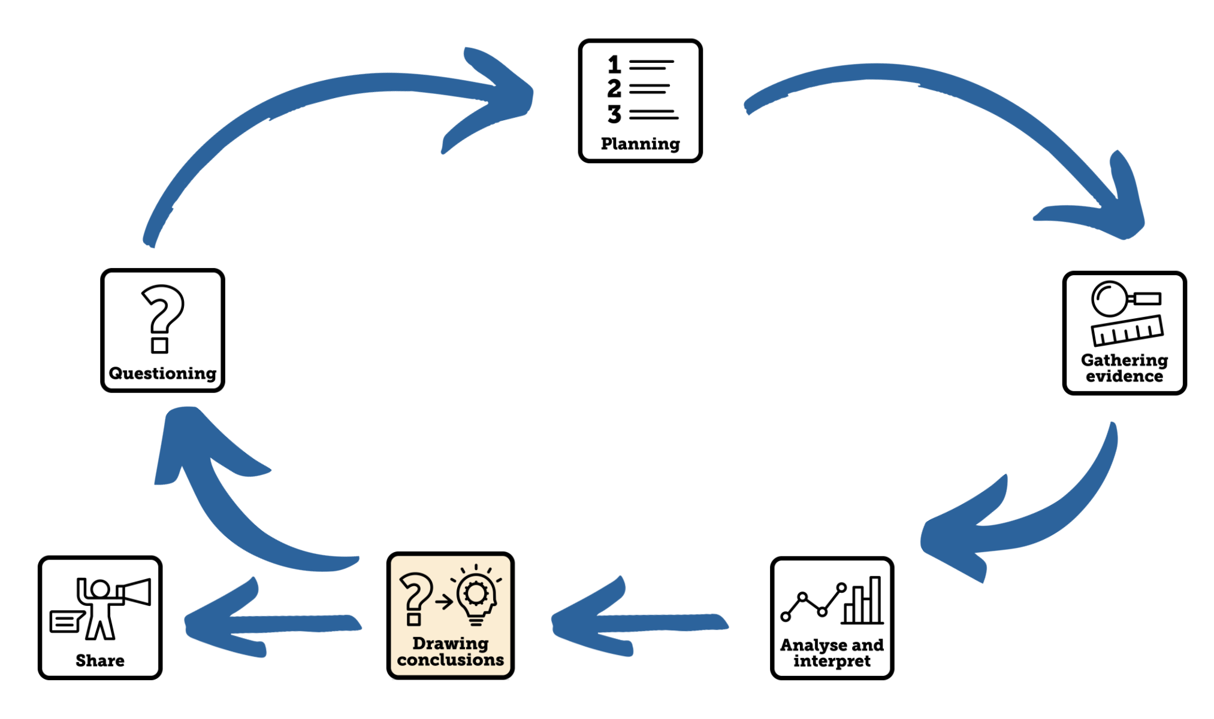

Aim of the video
This Science Skills Starter video supports young children in using the evidence they have gathered to answer their scientific question and draw a conclusion. It links back to the previous Science Skills Starter video where children learnt different ways to analyse and interpret their findings, supporting children in the next steps of developing this analysis into a conclusion. The video models how to use evidence to answer scientific questions and how to justify those answers by referring to the evidence.

Using the video
- The video begins revisiting some evidence that he analysed and interpreted in the previous video about animals’ senses. Dr Chips uses this evidence along with our Conclusion Creator tools to model how to draw conclusions:
  - First, he models drawing a conclusion from his Venn diagram that groups animals with ears he can see and those that do not have ears he can see, answering the question ‘Do all animals have ears?’ and using his evidence to justify his answer.
I have found out that not all animals have ears because I observed that dogs and horse have ears that I can see but frogs and snakes to do not.

  - Then he develops his conclusion further by using the Carroll diagram to answer the question ‘Do some groups of animals have ears and some not?’, again answering the question and then using his evidence to justify that answer.
I have discovered that most mammals have ears. I have also noticed that amphibians and reptiles don’t have ears. I could clearly see ears on elephants and mice but couldn’t see any ears on frogs or turtles.

  - Finally, he uses the pictogram and block diagram to answer the question ‘Does the size of an animal’s ear affect how well they can hear?’
I have discovered animals with bigger ears might be able to hear quiet sounds from a bigger distance. When I had big paper cone ears I could hear the quiet sound from the phone from 13 footsteps away but without any paper cone I had to stand 7 footsteps away to hear the sound.

- The children are challenged to draw conclusions about how the weather changes with the seasons using the various charts, tables and diagrams interpreted in the previous video. They use the evidence provided in the charts to draw a conclusion that answers the question ‘How does the weather change in different seasons?’ Children can use the Conclusion Creator tools to support them, the frames can be used to focus on the question and the evidence and the Conclusion Creator provides sentence starters to help them structure their conclusions.
- The video ends by linking the skill that has been learnt to the children’s current science learning. You could make drawing conclusions a focus for your next science lesson where sufficient time in given for children to practice this skill and reflect on their success in this demonstrating this skill. Use formative assessment and feedback to really focus on planning as a skill.

Tips to further develop this skill with your children
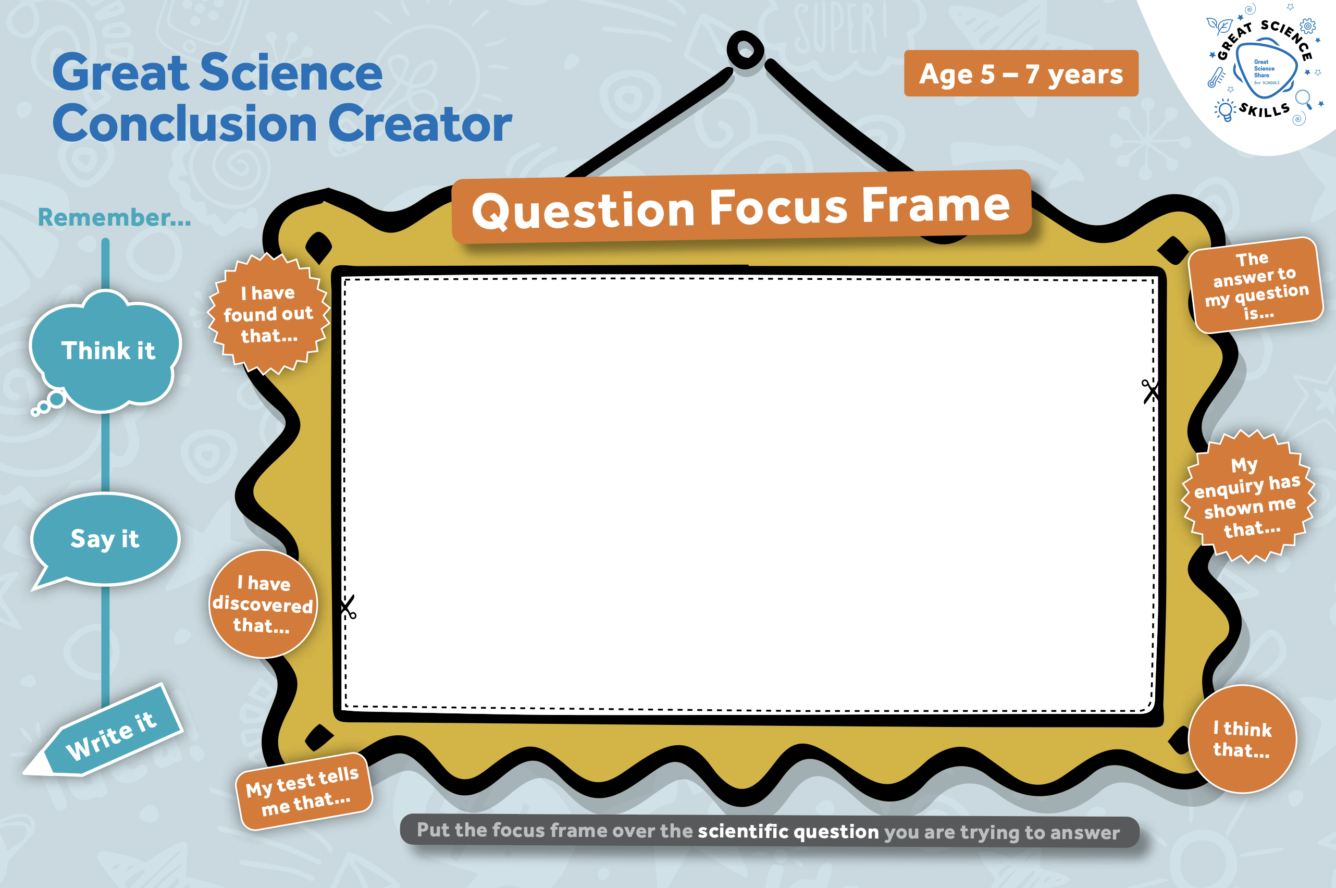
- Use the Focus Frames when your children are engaged in enquiry work to gather evidence to answer scientific questions. This will give them support to focus on the scientific question they are answering and the evidence that will help them answer it while they are thinking and talking about their conclusion.
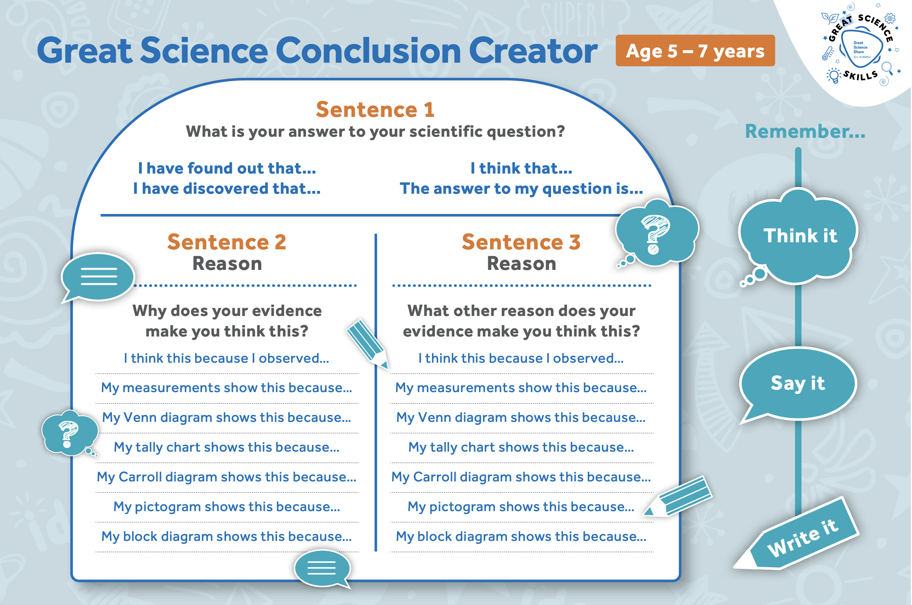
- Keep copies of the Great Science Conclusion Creator to hand to support children when orally practicing or writing drawing conclusions to support them in structuring their answers to scientific questions and identifying the key evidence they have that supports their answers.
- Provide opportunities for children to share their conclusions with new audiences.

Author: Amanda Poole
Editor: Dr Lynne Bianchi

Disclaimer: The Great Science Share for Schools are not liable for the actions of activity of any persons who uses this resource or in any of the suggested further resources. We assume no liability with regard to injuries or damage to property that may occur as a result of using this information. These activities are designed to be carried out by children working with an adult. The adult is fully responsible for ensuring the activity is carried out safely. You can access further H&S advice from www.cleapss.org.uk.

© 2022 The University of Manchester. These resources have been produced by the Great Science Share for Schools’ team. For more information visit www.greatscienceshare.org or contact greatscishare@manchester.ac.uk.

