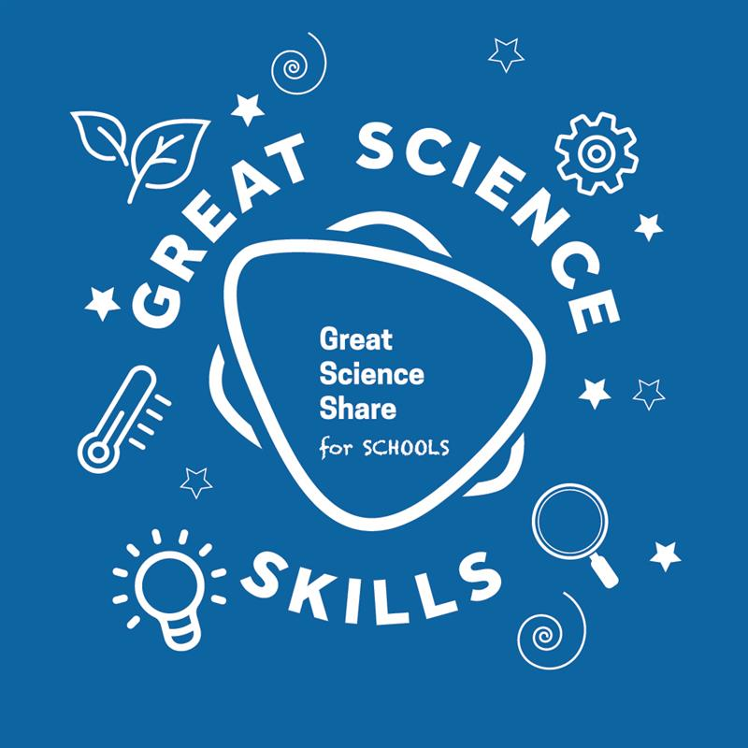
GREAT SCIENCE SKILLS STARTERS

Teacher notes
5-7 years: Gathering evidence

Children need to develop their scientific skills through enquiries that are clearly related to the science knowledge they are developing. They need to be explicitly taught science skills such as asking relevant questions, carrying out simple tests, gathering and recording evidence and using that evidence to answer questions, to help them develop greater independence in carrying out their own investigations.

These teacher notes and accompanying video are designed to help younger children develop the skills of gathering and recording evidence which they can then demonstrate when carrying out investigations to answer their own scientific questions for the Great Science Share for Schools. The gathering and recording of evidence provides useful opportunities for children to focus on key scientific vocabulary and apply their mathematics skills to their science learning.

The evidence gathering stage of the scientific process
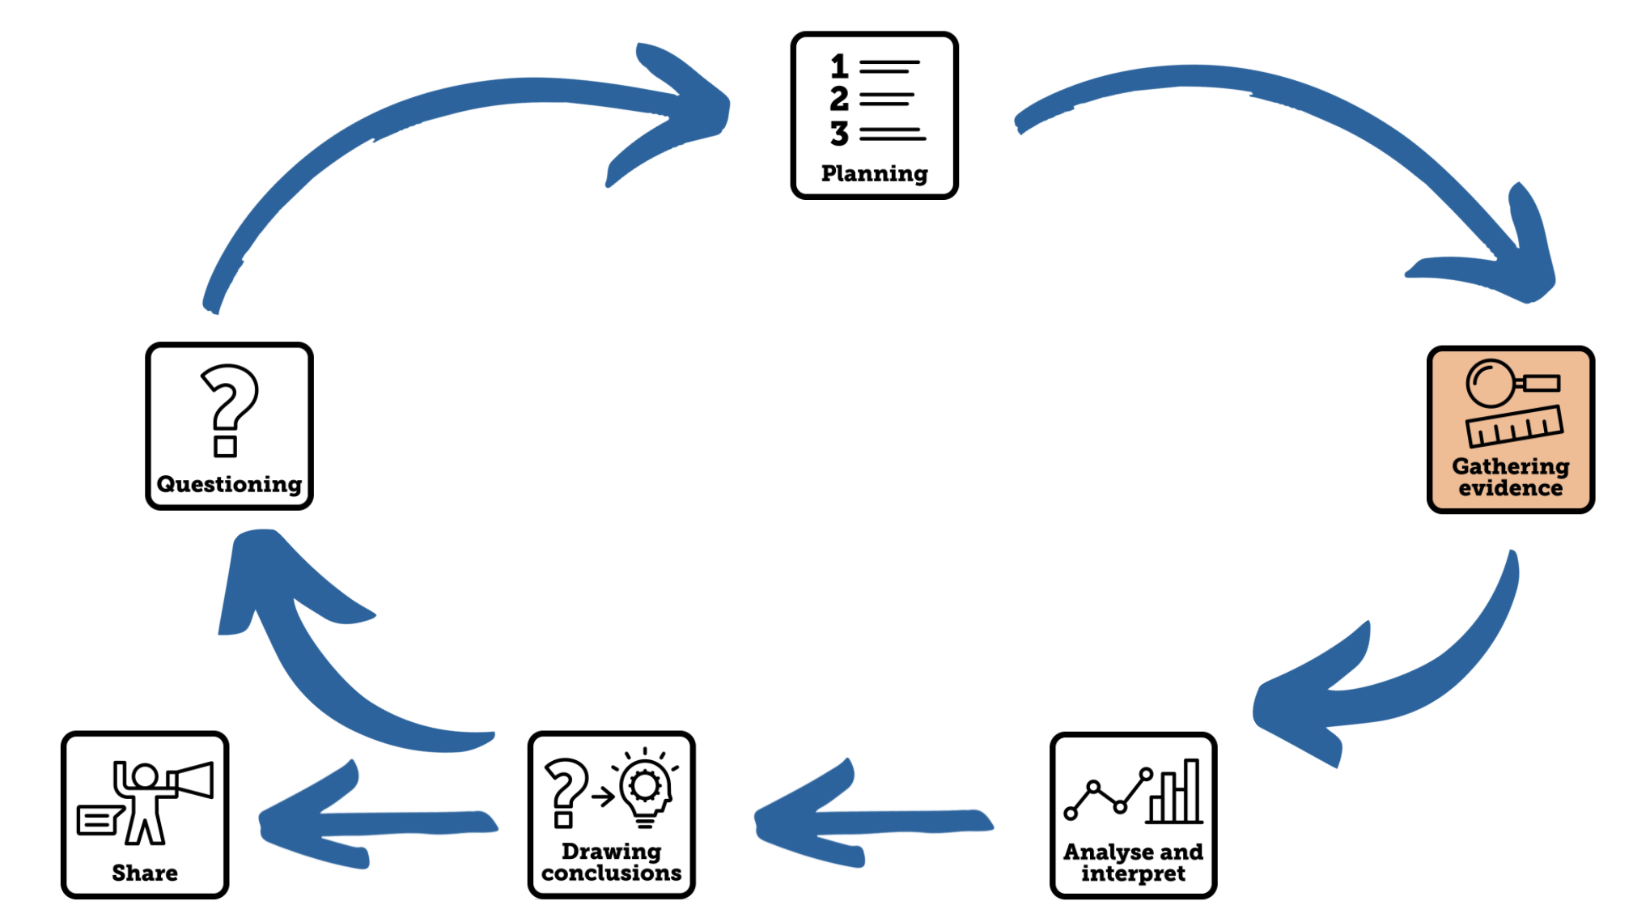

Aim of the video
This Science Skills Starter video supports young children in gathering evidence to help answer their scientific questions. It models how to make and record careful observations and introduces the idea of making simple measurements to help answer questions. Although the skill of planning simple tests and enquiries is not expected for younger learners, discussing how you will make careful observations and measurements as well as how and why they will help to answer the scientific question begins to involve children in decisions about the planning process.

Using the video
- The video begins with a scientific question being shared related to a real-life situation. Dr Chips wants to answer the question, ‘Which would be the best material to use for a blind that will block the streetlight at night?’. Children could either observe Dr Chips test the materials or you could provide some simple equipment to groups so that they can copy the steps that are modelled.
Resources needed: Materials to test (labelled), torch, magnifying glass, data logger or light sensor app such as LUX: Light meter FREE, table to record observations and measurements
  - Begin by testing each material to first see if you can see through it and then if you can see torch light through it.

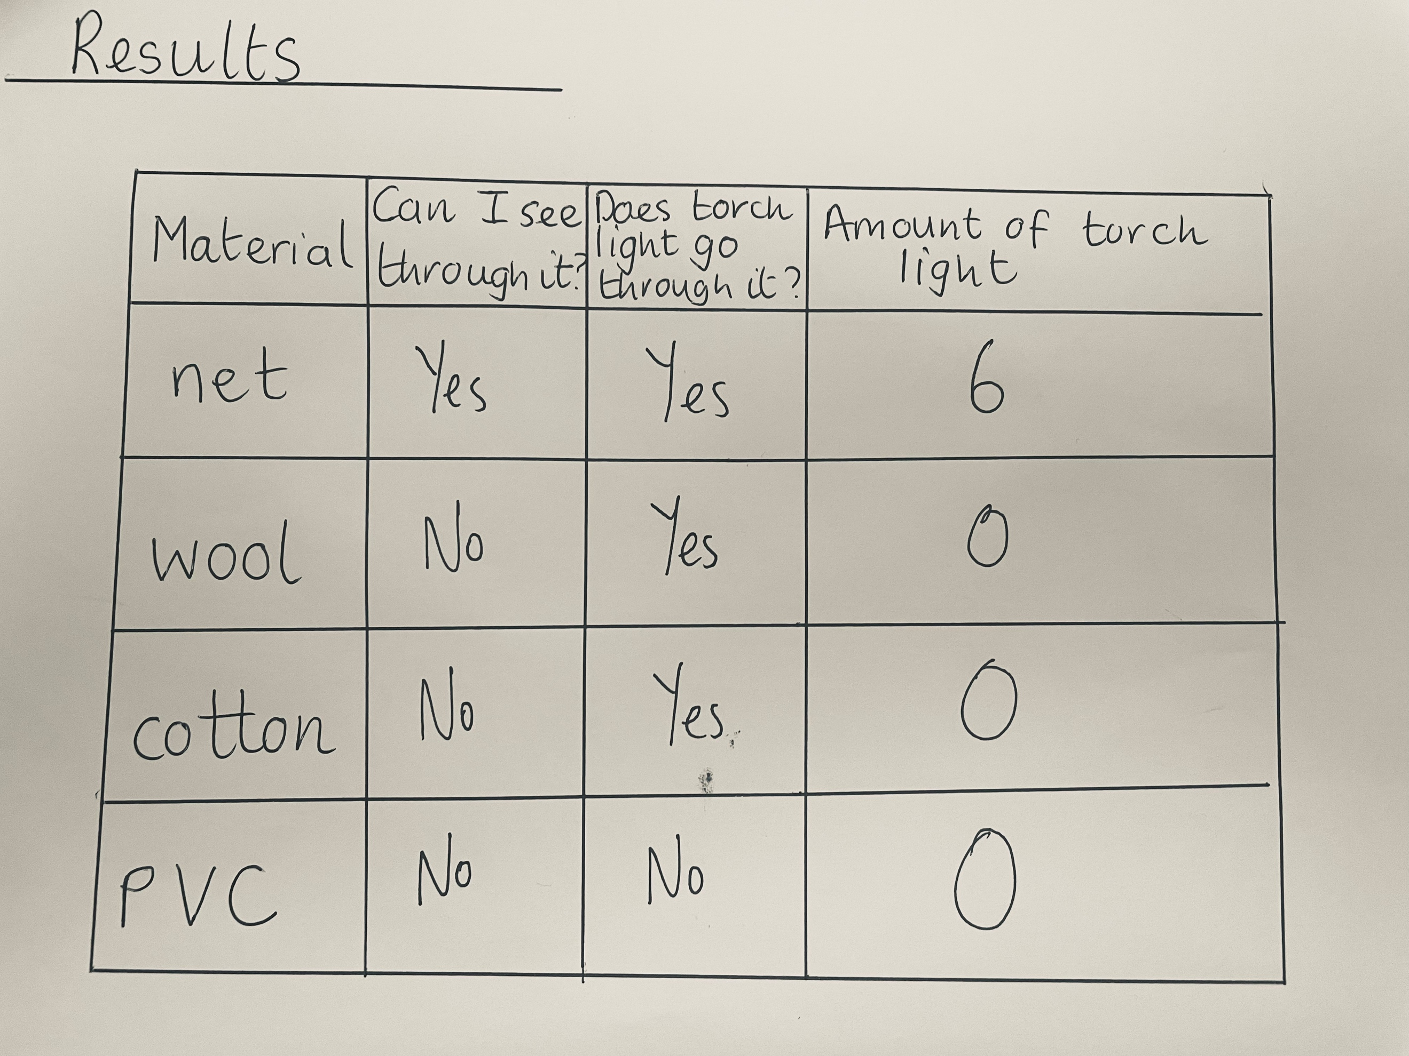
  - Then use a magnifying glass to take a closer look at the materials – if children carry out this test themselves, they can either describe their observations in words, photograph or a scientific drawing, these observations will help them to explain their findings.
  - If your school has access to microscopes these could be used for even closer observations which could also be captures with a photograph that children could label or annotate.
  - Dr Chips explains that scientists also make measurements to help them answer their questions and then models this by using a light sensor to measure the amount of torch light that passes through the materials, gathering data that can also be recorded in the table.
- Images are then shared of two different leaves and children are asked to make careful observations to answer the question, ‘How are these two leaves similar and how are they different?’ (Leaf 1 = Holly, Leaf 2=Ivy).
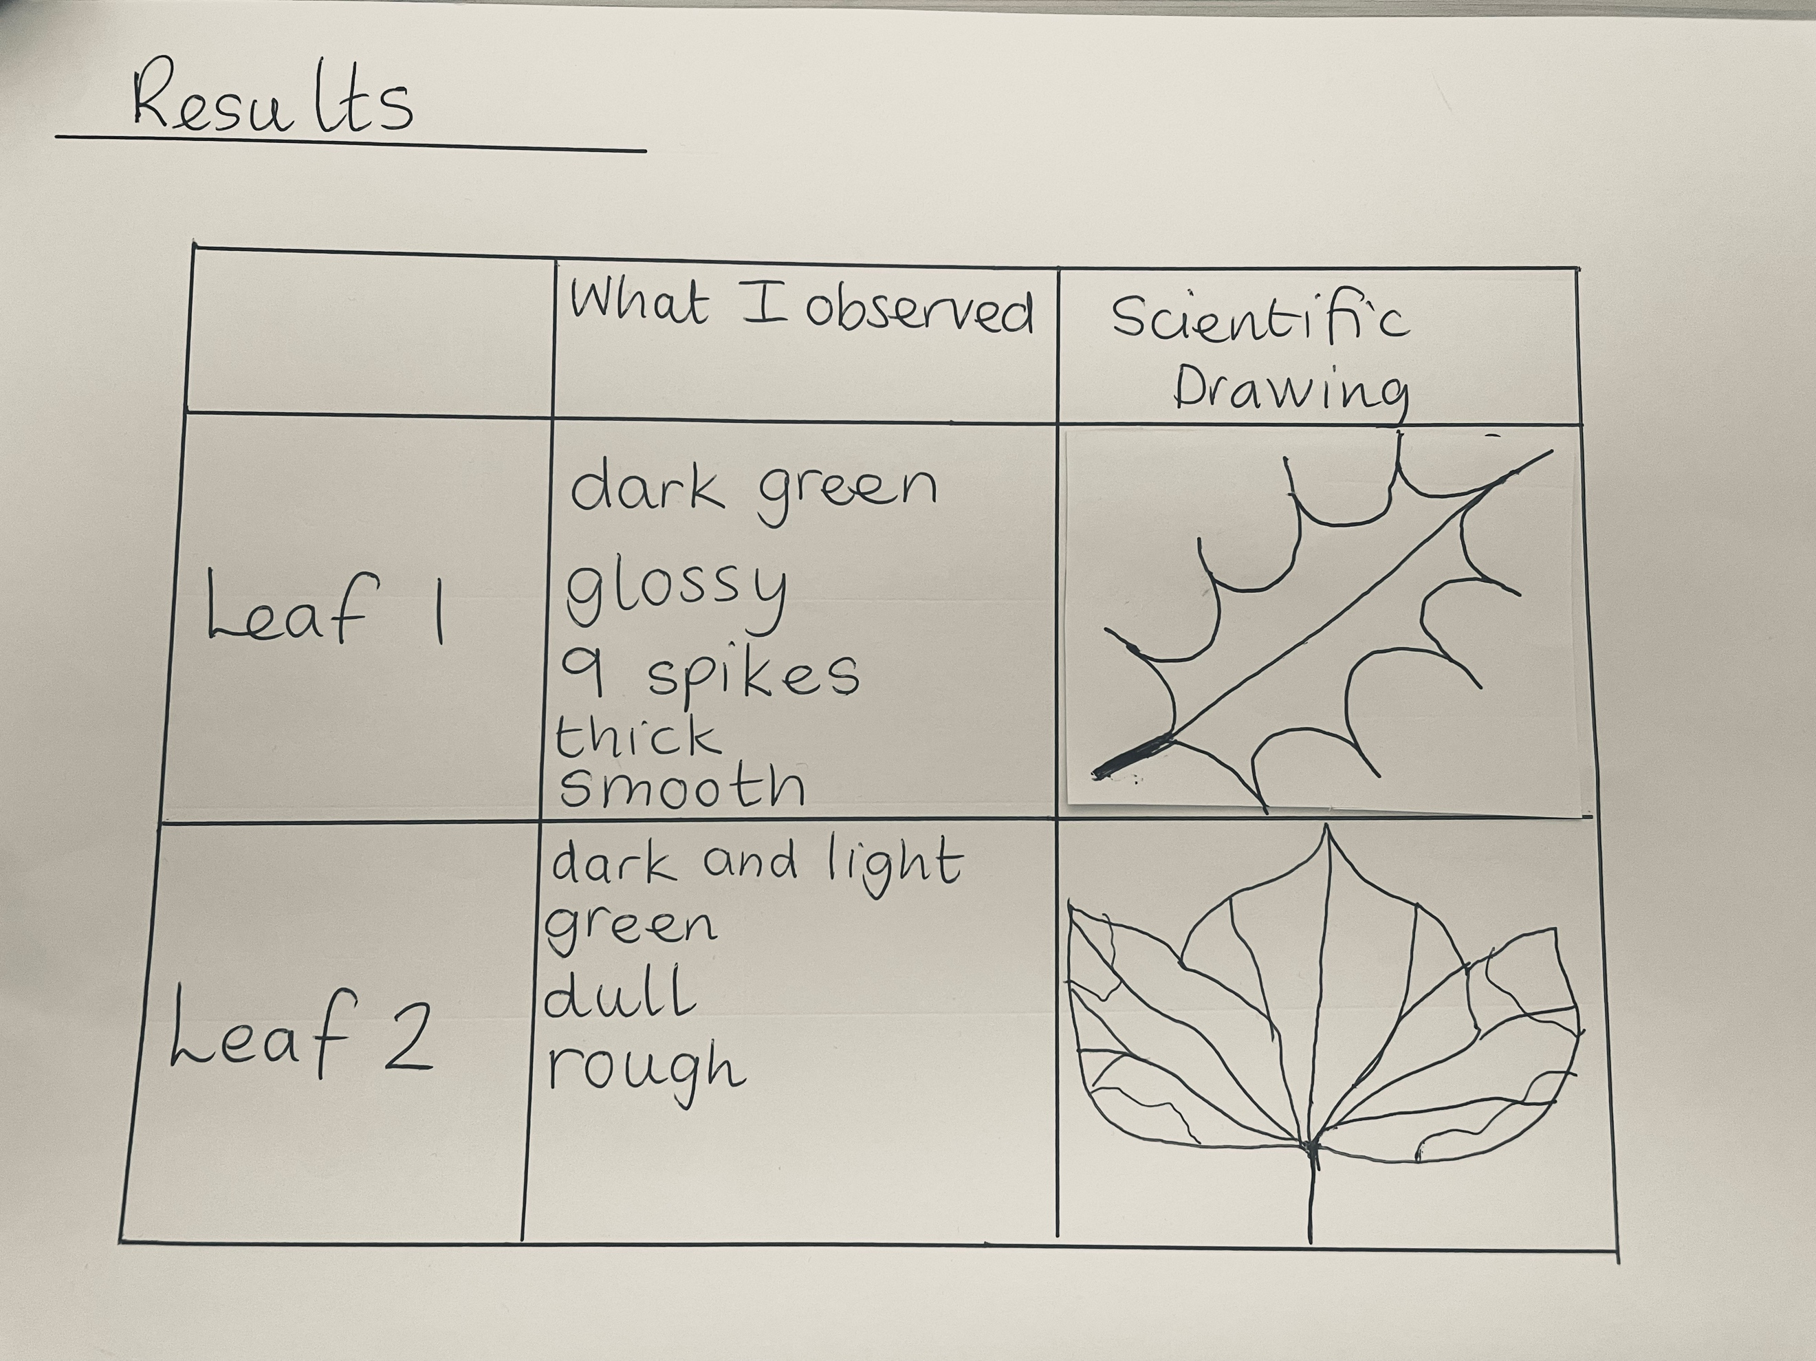
Pause the video on the three images that you can then pause on for the children to make and record their careful observations and measurements.
- In the first image children will notice obvious different between the two leaves such as colour and shape
- In the second image, when children look closer through the magnifying glass they will start to observe finer details such as the texture, veins and edges of leaves.
- Children might use the third image to estimate the size to the leaf and measure each to be almost 6 cm long but leaf 2 is much wider (around 6cm) than leaf 1 (around 2cm).

- The video ends by linking the skill that has been learnt to the children’s current science learning. You could make gathering and recording evidence a real focus for your next science lesson with children making and recording careful observations and measurements in a variety of ways. Use formative assessment and feedback to really focus on planning as a skill.

Tips to further develop this skill with your children

- Allocate regular time for children to practice recording their observations in scientific drawings where they really take the time to record what they observe. Encourage children to label features and using scientific vocabulary as well as descriptive language, giving them time to practice using a pencil and ruler to draw arrows to label those features.
- When children make more careful observations using magnifying glasses or microscopes, support children in taking photographs of their observations. Photographs can also be labelled to encourage children to identify and describe the things they have observed.
- There are many opportunities for young children to make simple measurements to answer their scientific questions in all science topics and this has a strong connection with their learning in mathematics. While younger children might find it challenging to make the measurements, they can use comparative vocabulary to compare quantities such as length/height, mass/weight, capacity/volume, and time as well as measuring in arbitrary units such as finger width, handspan, feet or paces which could be recorded in a tally chart.
- Children can also gather other simple data to answer scientific questions and make comparisons by keeping tally charts when counting objects, features or events.
- As skills in mathematics develop, children will be able to start taking measurements with support:
  - rulers and trundle wheels to measure in centimetres and metres,
  - thermometers to measure in ºC,
  - measuring jugs and measuring cylinders to measure in litres and millilitres
  - clocks or timers to measure in minutes or hours
and planning regular opportunities for children to do this will help them develop confidence and see the value of their maths measuring skills.

The table below suggests examples of ways that children can gather evidence to answer scientific questions.

Science Learning | Suggestions of data that can be collected to help answer scientific questions
human body | - measuring and comparing heights, lengths of limbs, fingers, feet (cm/m)  - measuring and comparing mass (g/kg)  - Measuring body temperature before and after different exercises (ºC)
animals | - Comparing the heights, lengths and masses of different animals through research or through careful first-hand measurements with support if rearing caterpillars, stick insects or chicks in school or looking after a pet at home (cm/m)  - Keeping a tally on animals with specific features on a zoo/farm visit such as skin type/number of limbs etc
plants | - Keeping a tally of the number of leaves/flowers on a plant over time  - Measuring the heights of plants/size of leaves over time (cm/m)  - Measuring the amount of water given to plants (drops/ml)  - Measuring the brightness of light where the plants are growing with a light sensor (lux)  - Measuring the temperature where a plant is growing (ºC)
materials | - Measuring the length of stretched materials to compare them(mm/cm)  - Measuring the amount of light that can travel through different materials (Lux or UV Index)  - Keeping a tally of the number of weights held by different boats before they sink  - Keeping a tally of the number of weights supported by different shaped paper bridges before they collapse.
weather and seasons | - Keeping a tally of sun hours in a day  - Keeping a tally of rain days in a week  - Measuring outside temperature (ºC)  - Measuring capacity of rainfall in a week/month (mm)  - Measuring UV index with a UV bead  - Measuring length of shadows during the day (cm)

Author: Amanda Poole
Editor: Dr Lynne Bianchi

Disclaimer: The Great Science Share for Schools are not liable for the actions of activity of any persons who uses this resource or in any of the suggested further resources. We assume no liability with regard to injuries or damage to property that may occur as a result of using this information. These activities are designed to be carried out by children working with an adult. The adult is fully responsible for ensuring the activity is carried out safely. You can access further H&S advice from www.cleapss.org.uk.

© 2022 The University of Manchester. These resources have been produced by the Great Science Share for Schools’ team. For more information visit www.greatscienceshare.org or contact greatscishare@manchester.ac.uk.

