GREAT SCIENCE SKILLS STARTERS

Teacher notes
7-11 years: Analysing and Interpreting data

Children need to develop their scientific skills through enquiries that are clearly related to the science knowledge they are developing. Children need to be explicitly taught science skills such as planning different types of enquiries, gathering accurate and precise measurements, analysing data with graphs and charts, drawing well developed conclusions, and evaluating methods and data.

These teacher notes and the accompanying video are designed to help children aged 7-11 develop the skill of using scatter graphs, bar charts and line graphs to analyse the data gathered in enquiries to spot trends, compare data and identify causal relationships.

The analysis and interpretation stage of the scientific process
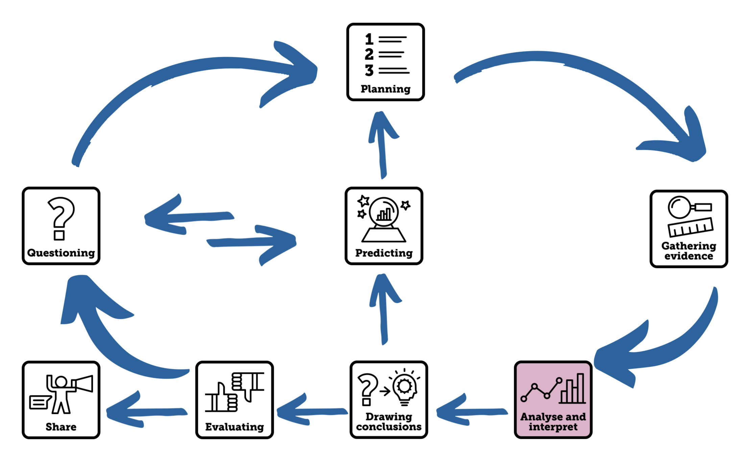
Aim of the video
This Science Skills Starter video supports children aged 7-11 as they develop their science skills, becoming increasingly accurate, analytical, and reflective as well as more independent in carrying out investigations. This video focuses on the skills of using graphs and charts to analyse and interpret the data that is gathered in science investigations. Children will learn how to be successful in drawing scatter graphs, bar charts and line graphs as well as the right time to use them. They will also become familiar with the types of questions they should ask of their data to interpret their evidence so that it can be used to answer questions.

Using the video
- The video begins with different ways that data from investigations can be analysed being modelled. Dr Chips explains that the type of enquiry you carry out often determines the best way to analyse your data giving examples of a scatter graph being suitable for pattern seeking enquiries, a bar chart for comparative tests and a line graph for fair tests.
- An example of each type of graph is given to explains what they show and how to be successful in drawing one. Dr Chips then explains that once the charts and graphs have been drawn, we must ask questions of the data to interpret the graphs and gives examples for three different investigations:
  - Pattern Seeking – Is your heartbeat faster if you are taller? Drawing and interpreting a Scatter Graph
  - Comparative test – Which type of eye protection is best at blocking dangerous light from the Sun? Drawing and interpreting a Bar Chart
  - Fair test: How does increasing the voltage across a buzzer affect its volume? Drawing and interpreting a Line Graph
- The children are then challenged to interpret a scatter graph, bar chart and line graph themselves by asking questions of the data.

Pause the video on each slide to allow time to discuss the questions in pairs and share their ideas.
  - Pattern Seeking – Are taller people always heavier? Drawing and interpreting a Scatter Graph
  - Comparative test – Which type of soil absorbs the most water? Drawing and interpreting a Bar Chart
  - Fair test: How does the distance between an object and the screen affect the size of its shadow? Drawing and interpreting a Line Graph

- The video ends by linking the skill that has been learnt to the children’s current science learning. The children are reminded of the different charts and graphs they could use to analyse their enquiries. You could make drawing and interpreting graphs a charts a focus for your next science lesson by collecting together examples of each type of graph and chart connected to your current science topic. Use formative assessment and feedback to really focus on planning as a skill.

Tips to further develop this skill with your children
- Regularly make time for children to interpret Venn & Carroll diagrams, branched keys, scatter graphs, bar charts and line graphs that are linked to their science learning. The type of enquiry that children carry out often dictates the type of chart they will use to analyse their data (See the illustration on the next page).
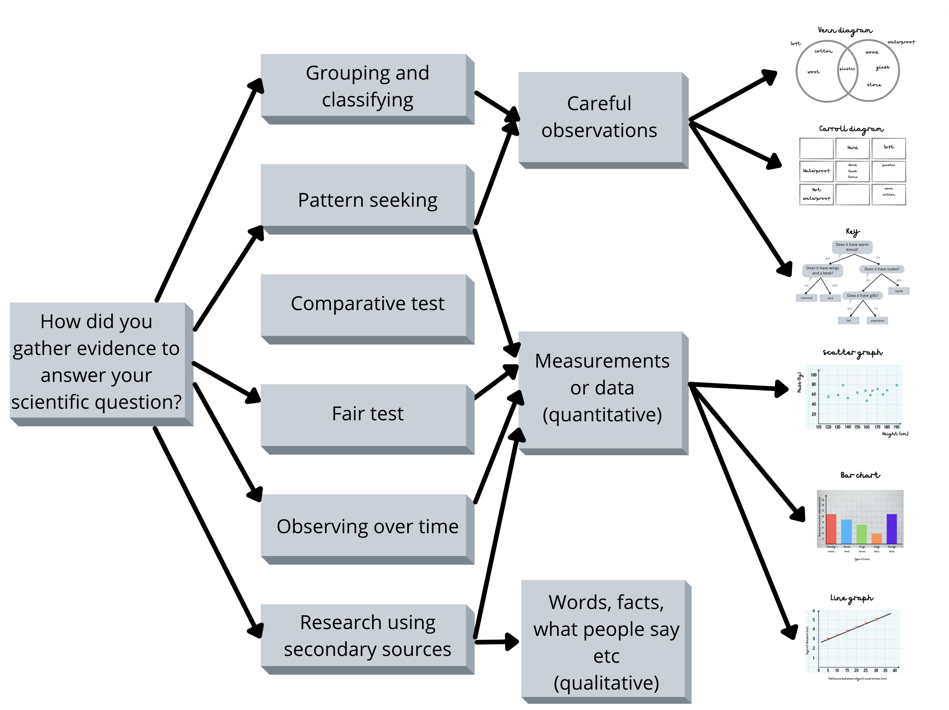

- Provide time for children to ask questions of the data they present in tables, graphs and charts by providing them with structured questions and facilitating paired talk time to share their ideas with a partner and then with the class.

This table suggests some questions you might like to ask of the different type of charts and tables.

Type of chart | Suggestions of the types of questions you could ask
Venn diagram | - Which is the largest/smallest group?  - Do the items in the overlap have anything else in common?  - How does the Venn diagram help you answer your question?
Carroll diagram | - Are there any empty categories? Which is the most common category? How does this help you answer your question?  - Do you notice any trends? Is it more likely that if an item is in a particular column, it will be in a particular row too?  - What new questions do you have?
Branched Keys | - Can you see any trends or patterns in the line on your graph?  - Describe the relationship between the variable you changed and the variable you measured.  - How does the trend in the data help you answer your question?  - What groups can you identify from your key? What similar characteristics do things in that group have? What differences do things in that group have?
Scatter Graph | - Can you see any trends or patterns in the line on your graph?  - Describe the relationship between the variable you changed and the variable you measured.  - How does the trend in the data help you answer your question?
Bar Chart | - Which is the tallest/shortest bar? How does that help you answer your question?  - What is the difference between the tallest and shortest bar?  - Can you use the bar to sort the items into order?
Line Graph | - Can you see any trends or patterns in the line on your graph?  - Describe the relationship between the variable you changed and the variable you measured.  - How does the trend in the data help you answer your question?

- Use graphs and charts as an enquiry starter to a topic or lesson, where children extract information from the charts and diagrams to make them curious about the subject matter and inspire them to ask further questions.
- Keep copies of interesting sets of data, graphs, and charts for investigations that you carry out every year as part of your curriculum, for children in future years to interpret.
- Find ways for children to share their interpretations of tables and charts with new audiences in new ways, you could even use our Share Spinner and Share Dice to help your pupils think about how they might share their analysis of findings from investigations.

Author: Amanda Poole
Editor: Dr Lynne Bianchi

Disclaimer: The Great Science Share for Schools are not liable for the actions of activity of any persons who uses this resource or in any of the suggested further resources. We assume no liability with regard to injuries or damage to property that may occur as a result of using this information. These activities are designed to be carried out by children working with an adult. The adult is fully responsible for ensuring the activity is carried out safely. You can access further H&S advice from www.cleapss.org.uk.

© 2022 The University of Manchester. These resources have been produced by the Great Science Share for Schools’ team. For more information visit www.greatscienceshare.org or contact greatscishare@manchester.ac.uk.

