GREAT SCIENCE SKILLS STARTERS

Teacher notes
7-11 years: Drawing Conclusions

Children need to develop their scientific skills through enquiries that are clearly related to the science knowledge they are developing. Children need to be explicitly taught science skills such as planning different types of enquiries, gathering accurate and precise measurements, analysing data with graphs and charts, drawing well developed conclusions, and evaluating methods and data.

These teacher notes and the accompanying video are designed to help children aged 7-11 develop the more demanding skill of using their data, graphs, and charts to answer scientific questions and justify their thinking with scientific ideas by drawing conclusions, the accompanying Focus Frames and Conclusion Creators are designed to support children in practicing this skill independently.

The concluding stage of the scientific process
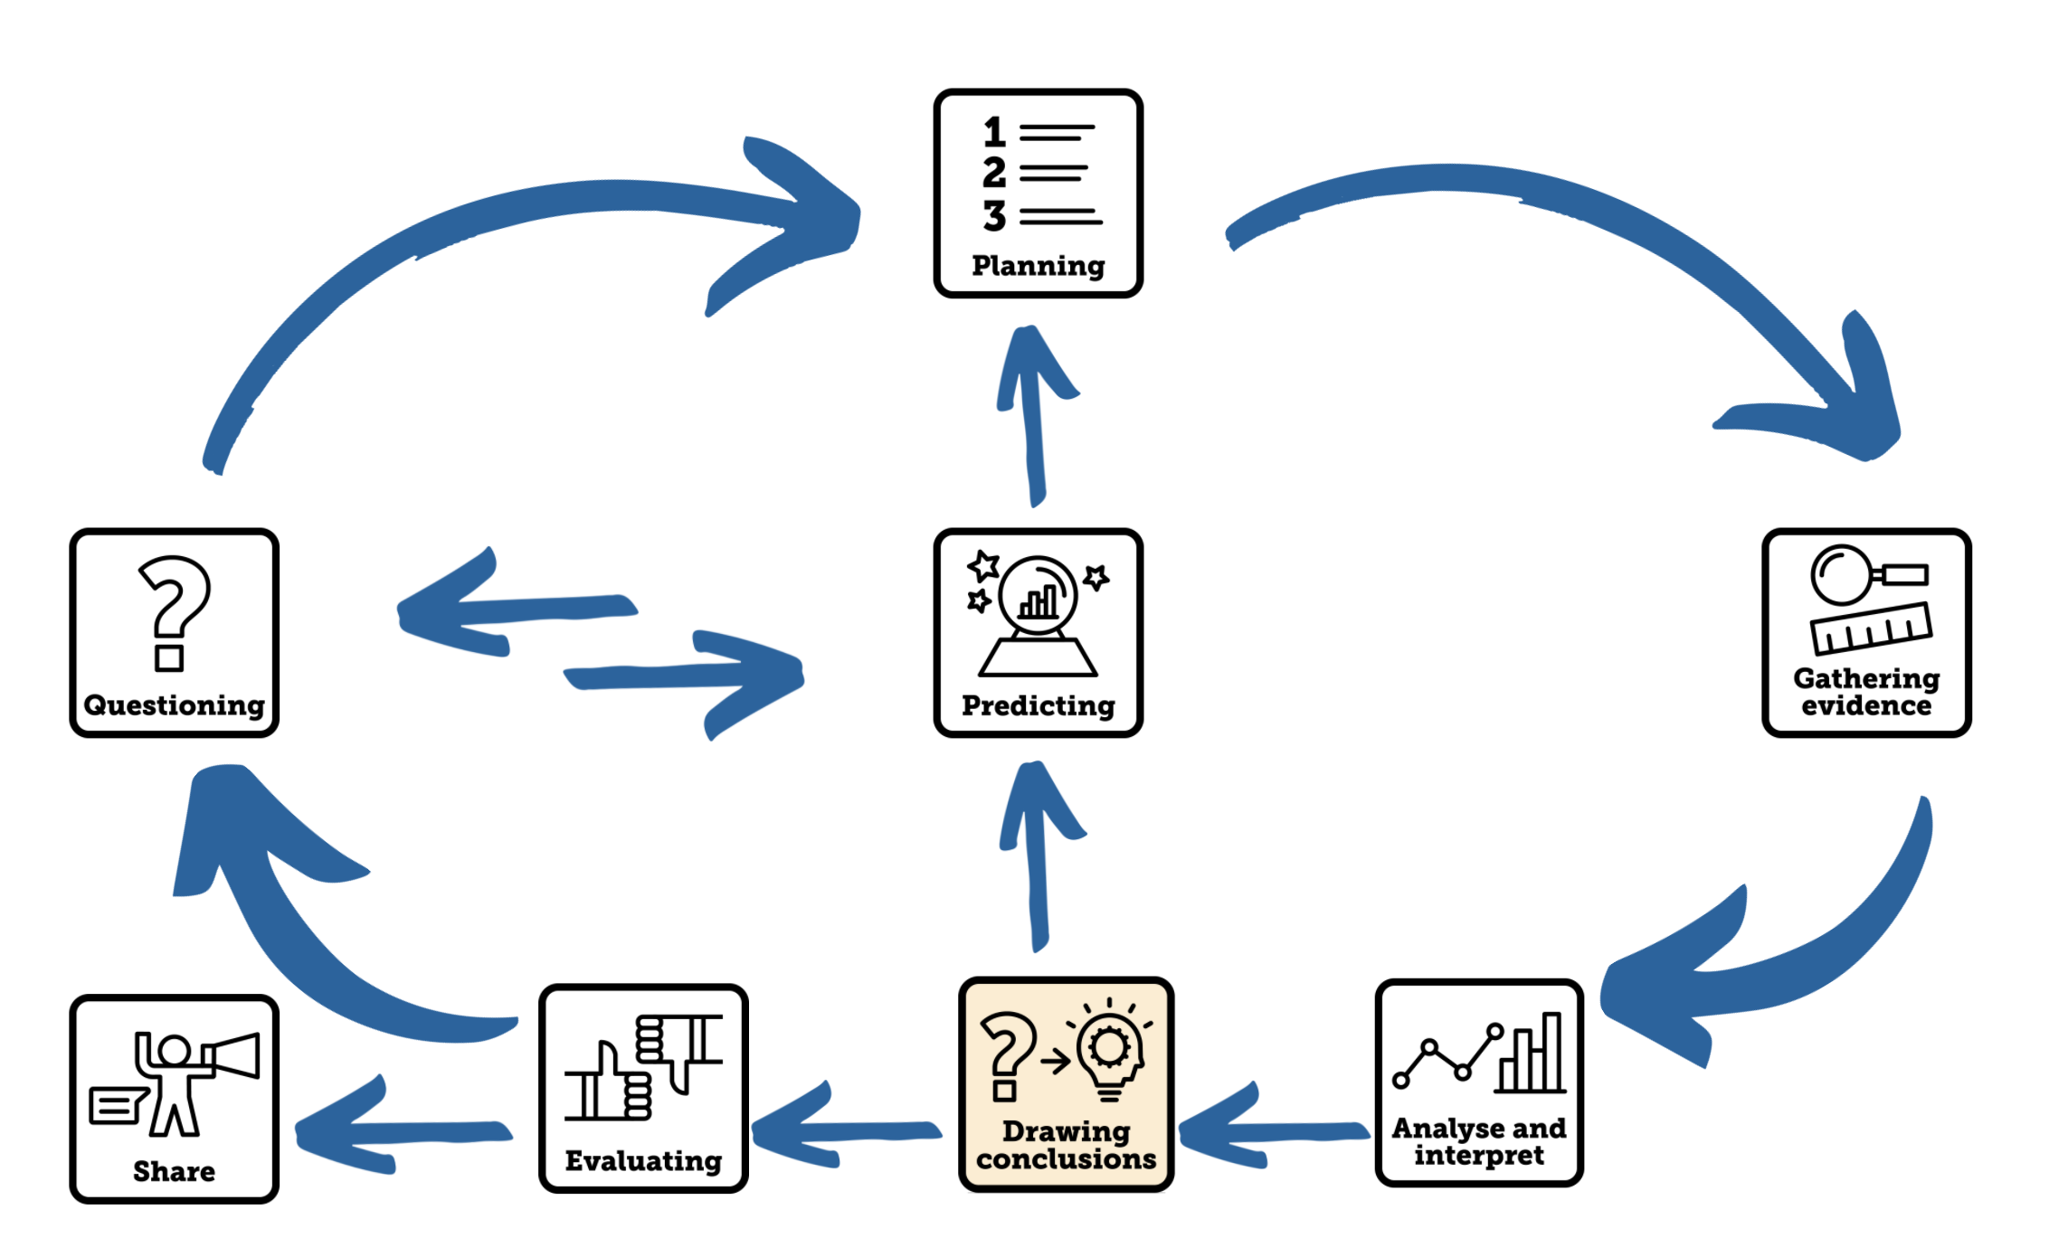

Aim of the video
This Science Skills Starter video supports children aged 7-11 as they develop their science skills, becoming increasingly accurate, analytical, and reflective as well as more independent in carrying out investigations. This video focuses on the skill of drawing well-developed conclusions, supporting children in making connections between the question they are trying to answer and the data they have collected, using their analysis and interpretation of their evidence to justify their answers, and using their own scientific ideas to explain their conclusions.

Using the video
- The video begins how to draw conclusions being modelled. Some of the questions and data used in the previous videos are considered to focus children’s attention on analysis and interpretation of data. Dr Chips considers the question he is trying to answer, the evidence that he has collected, and he forms his answer to the scientific question using a sentence starter from the Conclusion Creator to help him. Then he selects some of his data to justify and support his answer, then links it to science ideas using appropriate science vocabulary and finally he suggests further questions that need to be asked to understand even more. A summary of the steps taken to develop the conclusion is given.
- The children are challenged to develop conclusions from a bar chart and line graph. The question and data they are using is displayed in a Focus Frame. Firstly, a bar chart is used to answer the question, ‘Which soil absorbs the most water?’ and then a line graph is used to answer the question ‘Does the distance between an object and a screen affect the size of its shadow?’

Pause the video at this section to look at the graph or chart from which to develop a conclusion. Provide the children with a copy of the 7-11 Conclusion Creator to scaffold them with structuring their explanation.

- The video ends by linking the skill that has been learnt to the children’s current science learning. You could make drawing conclusions a focus for your next science lesson. Choose a line of enquiry where children will be able to easily see how their science learning can be used to explain their ideas. It is important that practical enquiries that children carry out in science are always clearly related to the science ideas and concepts they are learning. This will allow them to apply their science ideas and demonstrate their working scientifically skills at the appropriate level. Use formative assessment and feedback to really focus on planning as a skill.

Tips to further develop this skill with your pupils
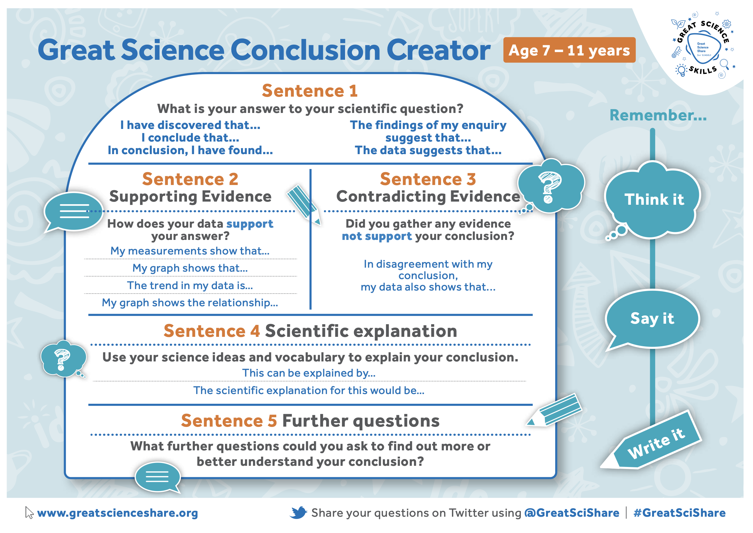
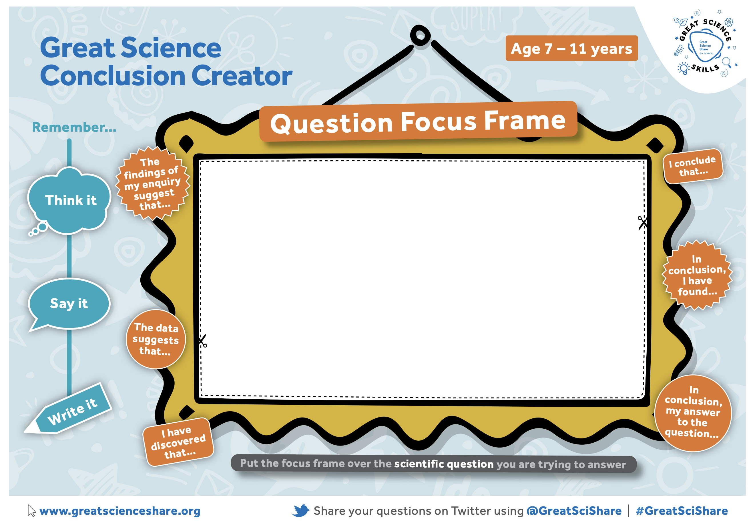
- Scaffolding thinking: Every time your pupils are engaged in enquiry work to gather evidence to answer scientific questions use the Focus Frames to support children in focusing on the scientific question they are answering and the evidence that will help them answer it while they are thinking and talking about their conclusion.
- Provide copies of the Great Science Conclusion Creator to support children when orally practicing or writing conclusions. This will support them in structure their answers to scientific questions and identifying the key evidence they have that supports their answers.
- Remember to provide opportunities for children to share their conclusions with new audiences.

Author: Amanda Poole
Editor: Dr Lynne Bianchi

Disclaimer: The Great Science Share for Schools are not liable for the actions of activity of any persons who uses this resource or in any of the suggested further resources. We assume no liability with regard to injuries or damage to property that may occur as a result of using this information. These activities are designed to be carried out by children working with an adult. The adult is fully responsible for ensuring the activity is carried out safely. You can access further H&S advice from www.cleapss.org.uk.

© 2022 The University of Manchester. These resources have been produced by the Great Science Share for Schools’ team. For more information visit www.greatscienceshare.org or contact greatscishare@manchester.ac.uk.

