GREAT SCIENCE SKILLS STARTERS

Teacher notes
7-11 years - Measuring accurately

Children need to develop their scientific skills through enquiries that are clearly related to the science knowledge they are developing. Children need to be explicitly taught science skills such as planning different types of enquiries, gathering accurate and precise measurements, analysing data with graphs and charts, drawing well developed conclusions, and evaluating methods and data.

These teacher notes and the accompanying video are designed to help children aged 7-11 develop the more demanding skill of making accurate and precise measurements when gathering evidence to help them answer their scientific questions.

The evidence gathering stage of the scientific process
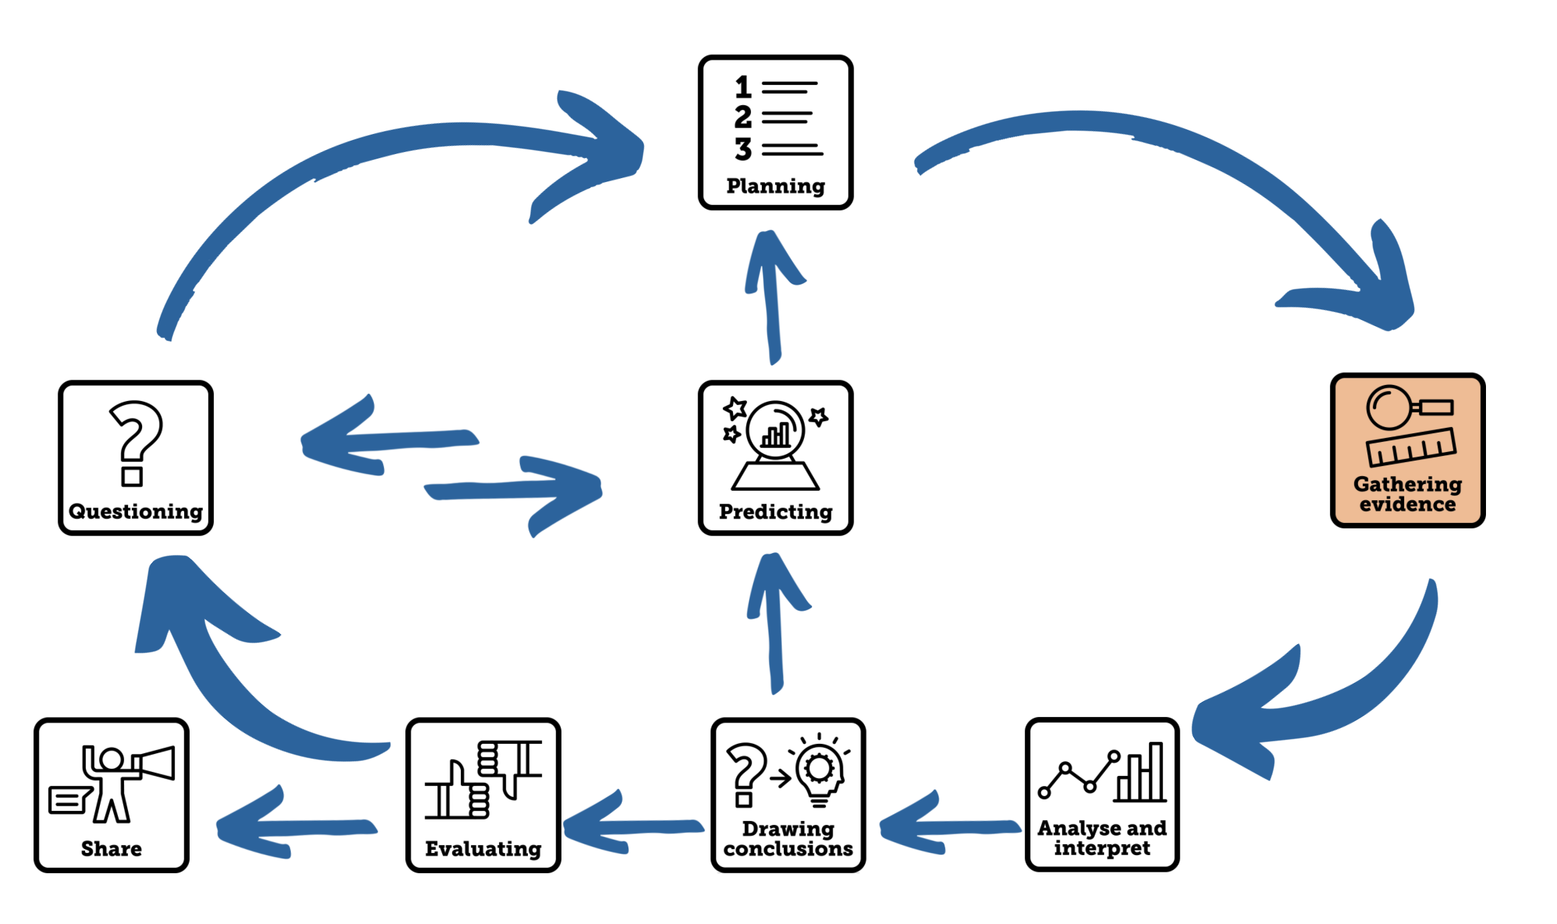

Aim of the video
This Science Skills Stater video supports children aged 7-11 as they develop their science skills, becoming increasingly accurate, analytical, and reflective as well as more independent in carrying out investigations. This video focuses on the skill of making accurate and precise measurements where children learn what accurate means and the importance of choosing the appropriate measuring device as well as the meaning of precise measurements and how to judge the precision of their data from their repeat measurements. In watching this video, children will becoming increasingly familiar with the wide range of measuring instruments they can use in their science enquiries.
Using the video
- The video begins with an explanation of the meaning of the terms accurate and precise and then using a variety of thermometers and stopwatches to demonstrate the meaning of the two scientific terms.
- Accurate means that the measurement you make is as close to the true value as it can be. How accurate your measurements are, depends on the measuring equipment you use.
- Precise means that when you take repeat measurements of the same thing, they are close to each other. You can comment of the precision of your data when you compare your repeat measurements.
- A variety of pieces of measuring equipment are shown that children might consider to use in their science enquiries.
- In the video, the children are challenged to have a go at making accurate and precise measurements. First, they read the outside temperature using images of glass thermometers that can be paused on the screen. They can make this measurement to the nearest ºC (Celsius).
If you have digital thermometers in school, the children should take them outside to make their own measurements to the nearest 0.1 ºC or 0.01 ºC depending on the accuracy of your digital thermometer. Record these measurements for children to comment on their precision back in class.
- Dr Chips shares an incomplete data table of the measurements he collected when a investigating a pendulum. Children read the time displayed on 3 stop watches and calculate the mean average.

Pause the video at the end of this section to give time for children to make the measurement for themselves and ask them to comment on the precision of Dr Chips’ data. Are all the measurements close together? Would you describe the data as precise?

- The video ends by linking the skill that has been learnt to the children’s current science learning. You could make time to focus on accurate and precise measuring in your next science lesson to allow the children use a variety of measuring instruments. Use formative assessment and feedback to really focus on planning as a skill.

Tips to further develop this skill with your children
- Remember that your children need to be taught the skill of using different pieces of measuring equipment and make time to model these skills. Give children practice and assess their ability to use pieces of equipment. Here are some examples of measuring equipment that children could be taught to use in their science investigations.

digital thermometer | glass thermometer | ruler | protractor
stopwatch | tape measure | trundle Wheel | measuring cylinder
pipette | scales | digital balance | datalogger
light sensor | sound sensor | newton meter | heart rate monitor

- Use technology to develop your pupils measuring skills by using data loggers to support observation of time enquiries where light, temperature or sound is measured. If you don’t have data loggers in school, there are a variety of free digital apps available for measuring and datalogging. Read The Ogden Trust’s Phizzi Focus: using technology when working scientifically for useful links and ideas of how to use technology when working scientifically.

Author: Amanda Poole
Editor: Dr Lynne Bianchi

Disclaimer: The Great Science Share for Schools are not liable for the actions of activity of any persons who uses this resource or in any of the suggested further resources. We assume no liability with regard to injuries or damage to property that may occur as a result of using this information. These activities are designed to be carried out by children working with an adult. The adult is fully responsible for ensuring the activity is carried out safely. You can access further H&S advice from www.cleapss.org.uk.

© 2022 The University of Manchester. These resources have been produced by the Great Science Share for Schools’ team. For more information visit www.greatscienceshare.org or contact greatscishare@manchester.ac.uk.

