GREAT SCIENCE SKILLS STARTERS

Teacher notes
7-11 years : Planning

Children need to develop their scientific skills through enquiries that are clearly related to the science knowledge they are developing. Children need to be explicitly taught science skills such as planning different types of enquiries, gathering accurate and precise measurements, analysing data with graphs and charts, drawing well developed conclusions, and evaluating methods and data.

These teacher notes and the accompanying video are designed to help children aged 7-11 develop the more demanding skill of planning different types of enquiries with a particular focus on variables that will be changed, measured and controlled as well as communicating plans in writing.

The planning stage of the scientific process
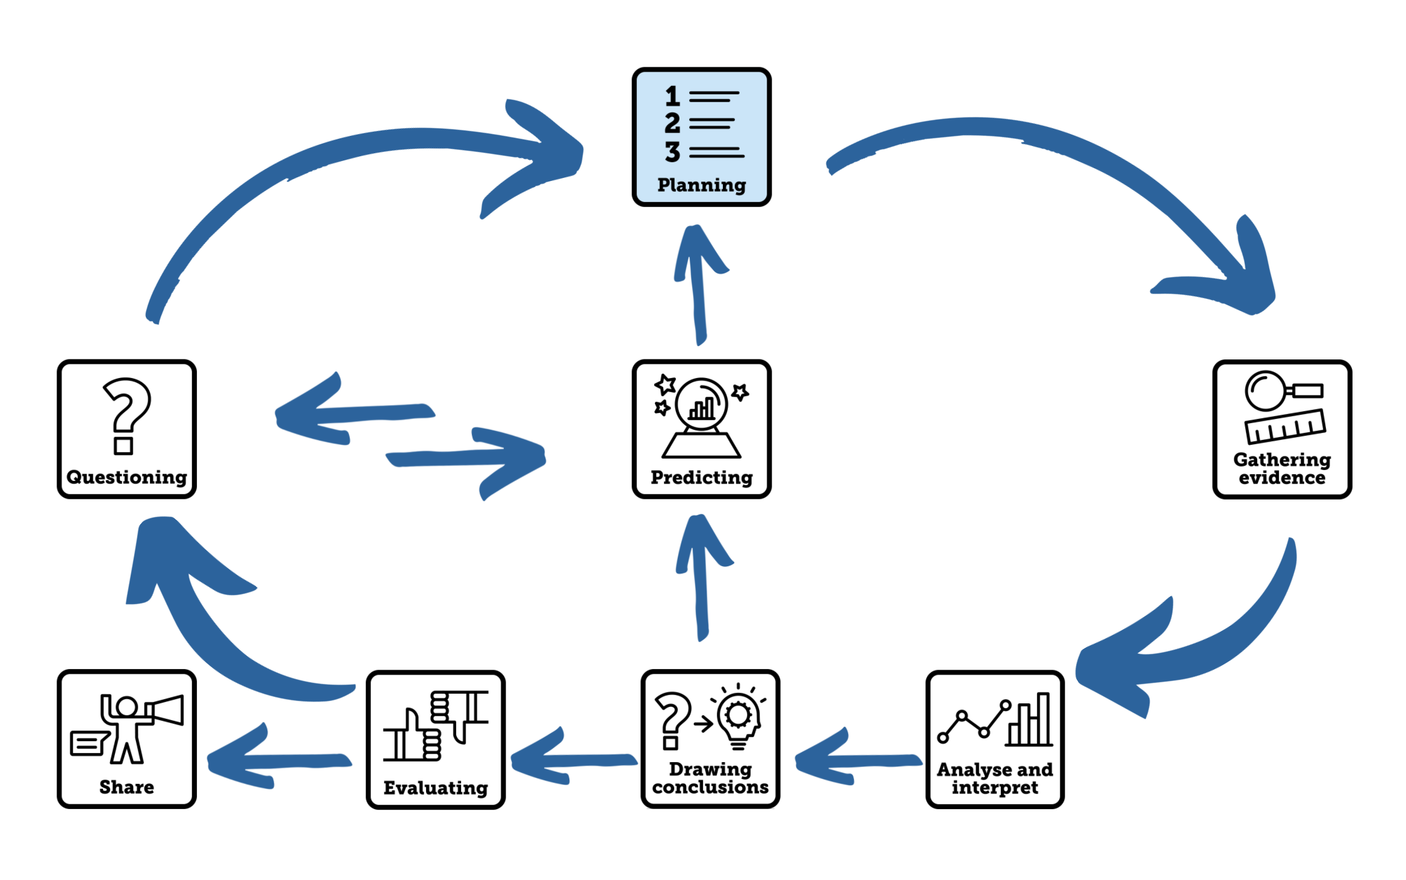
Aim of the video
This Science Skills Starter video supports children aged 7-11 as they develop their science skills, becoming increasingly accurate, analytical, and reflective as well as more independent in carrying out investigations. This video focuses on the skills of planning different types of enquiries and the things that need to be considered. There is a particular focus on comparative and fair tests with examples of variables that are changed, measured and controlled.
To further support children in applying their English language skills to record their plans in writing, the video also looks at how we report methods for investigations, showing how children can use the passive voice in their reporting.

Using the video
- The video begins with reviewing the different types of enquiries that could be carried out to answer scientific questions. In each case the type of enquiry is defined by the way in which evidence is gathered. Specific things that need to be thought about when planning each of the types of enquiry are highlighted for the children.
- Dr Chips then models the skill of planning by taking two scientific questions and describing how to go about gathering evidence to answer those questions.
- First a comparative test is planned to answer the question ‘Which soil is best at absorbing water?’. The variables to be compared is highlighted – in this case the type of soil. A list of what soils will be tested is given. The variable to be measured is then identified – in this case the volume of water that passes through the soil. This will be used to calculate the amount of water absorbed by the soil. Dr Chips also highlights the variables that will be controlled – in this case the amount of water poured onto the soil and the mass of soil. The equipment to be used to compare the soils and how he will use them is talked about.
- Secondly, he plans a fair test to answer the question “What happens to the brightness of a lamp when you increase the voltage (number of batteries) across the circuit?’. Dr Chips identifies the variable he will be changing – the voltage across the circuit (number of batteries), the variable he will be measuring – the brightness of the lamp and the variables he will be controlling – the type of bulb, the position of the light sensor/data logger, the background light level. The equipment to be used to compare the circuits and how they will use it is talked about.

Pause the video at the end of this section and challenge children to work in pairs to make a list of the equipment that is used to answer each question. This fun memory test will also help you make the point that an important part of planning an enquiry is choosing and listing all the equipment you will need.

- Next, Dr Chips Challenges the pupils to then practice the skill of planning themselves providing three questions that they can plan an investigation to answer:

  - Question 1: Which type of sugar dissolves faster? [Comparative test]
  - Question 2: How does my heart rate change over the day? [Observing over time]
  - Question 3: How does the loudness of a drum change if you stand further away? [Fair test]

Provide your children with alternative questions if you prefer that link to your current science topic. Less experienced children might find it helpful to have a tray of equipment in front of them to help them see what they would do – they can always suggest different pieces of equipment that aren’t provided.

Suggested equipment to provide for support (optional)
Question 1:  Which type of sugar dissolves faster? [Comparative test] | Question 2:  How does my heart rate change over the day?  [Observing over time] | Question 3:  How does the loudness of a drum change if you stand further away? [Fair test]
Icing sugar, sugar cube, granulated sugar, caster sugar, jug of water, measuring cylinder, stopwatch, beaker, stirring rod | Stopwatch, heart rate meter, clock, optional: data logger with heart rate sensor | Drum, beater, 20m tape measure, datalogger with sound sensor or tablet with sound meter app

- Dr Chips includes a very brief introduction to how to report investigation plans so that they can be shared with others, explaining what should be included in step-by-step instructions. He also shows how children can challenge themselves to report plans using the passive voice, applying their English skills to report plans in a more formal way.
- The video ends by linking the skill that has been learnt to the children’s current science learning. You could make planning a key focus in your next science lesson to allow your pupils to put their planning skills to the test. Use formative assessment and feedback to really focus on planning as a skill.

Tips to further develop this skill with your children
- Thinking about questions: It is important for children to spend time developing their own science questions linked to the topics they are studying. Try some of these approaches to develop question-asking in your classroom:
  - Use the Great Science Share Question Makers - a collection of tools to support children in asking scientific questions.
  - Set up a question wall or door in your classroom where children are encouraged to regularly display the scientific questions they come up with over the year. This can be used to really celebrate children’s curiosity and thinking. Why not have a Science Question of the week?
  - Establish a scientific question post-box where children can post their questions in relation to the current topic there are learning about in science. You could make time to sort the questions by the type of enquiry that could be used to answer them and organise children into groups to try and gather evidence to answer some of them.
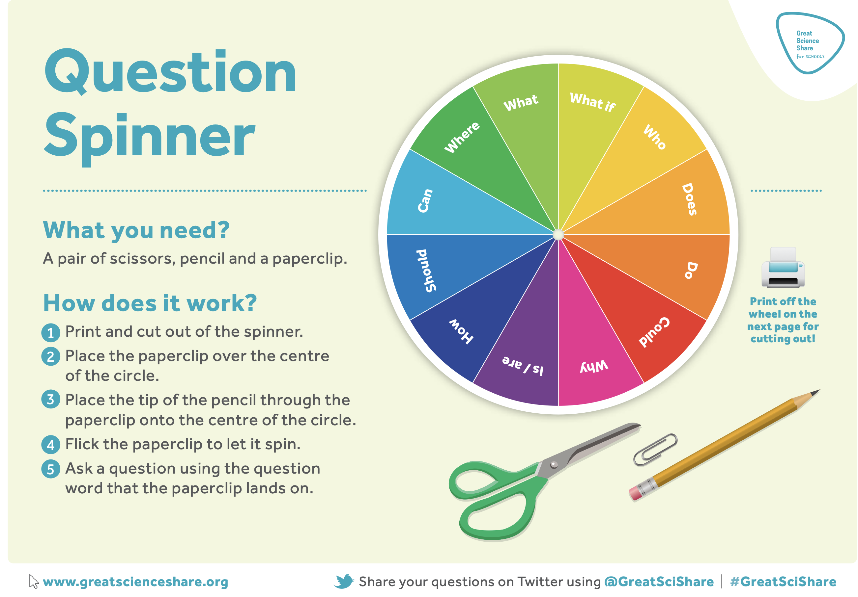
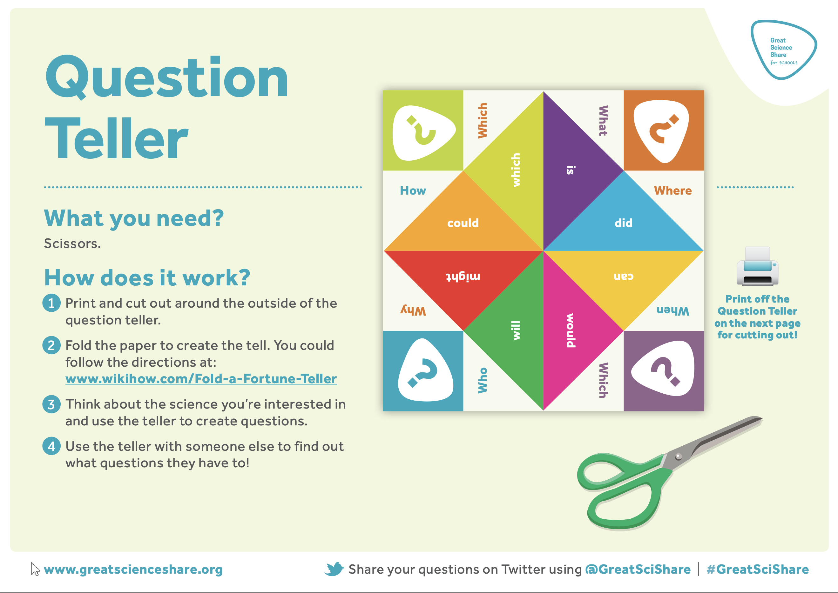
  - As a plenary activity at the end of a science lesson, ask children to independently create a list of all the questions they would want to ask to further their learning from the lesson or topic. What do they want to find out next to understand these ideas more?
This is a valuable opportunity to review children’s thinking and how they are linking ideas to the world around them as well as their prior learning. It is also an effective approach to identifying any misconceptions that children might have developed through their learning.

- Planning and doing: Remember it isn’t necessary for children to independently plan every practical investigation that you carry out in school. They also don’t need to do full investigations each time they have planned them. Sometimes you will plan collaboratively as a class and sometimes children will collaborate in small groups to plan investigations. In these cases, children may not be required to report their method. Nevertheless, it is important that children sometimes get the opportunity to plan their own investigations to answer a question and it makes sense that they demonstrate their learning by formally reporting their plan and sharing their ideas to be assessed.
- Learning about equipment: Why not introduce a wall display of labelled common pieces of equipment that children might use in their enquiries? This can be a support when they are planning their own enquiries.

Author: Amanda Poole
Editor: Dr Lynne Bianchi

Disclaimer: The Great Science Share for Schools are not liable for the actions of activity of any persons who uses this resource or in any of the suggested further resources. We assume no liability with regard to injuries or damage to property that may occur as a result of using this information. These activities are designed to be carried out by children working with an adult. The adult is fully responsible for ensuring the activity is carried out safely. You can access further H&S advice from www.cleapss.org.uk.

© 2022 The University of Manchester. These resources have been produced by the Great Science Share for Schools’ team. For more information visit www.greatscienceshare.org or contact greatscishare@manchester.ac.uk.

